Stack using a single Queue.
Note: Stack is a data structure that follows the Last In First Out (LIFO) rule.
Note: Queue is a data structure that follows the First In First Out (FIFO) rule.
Example:
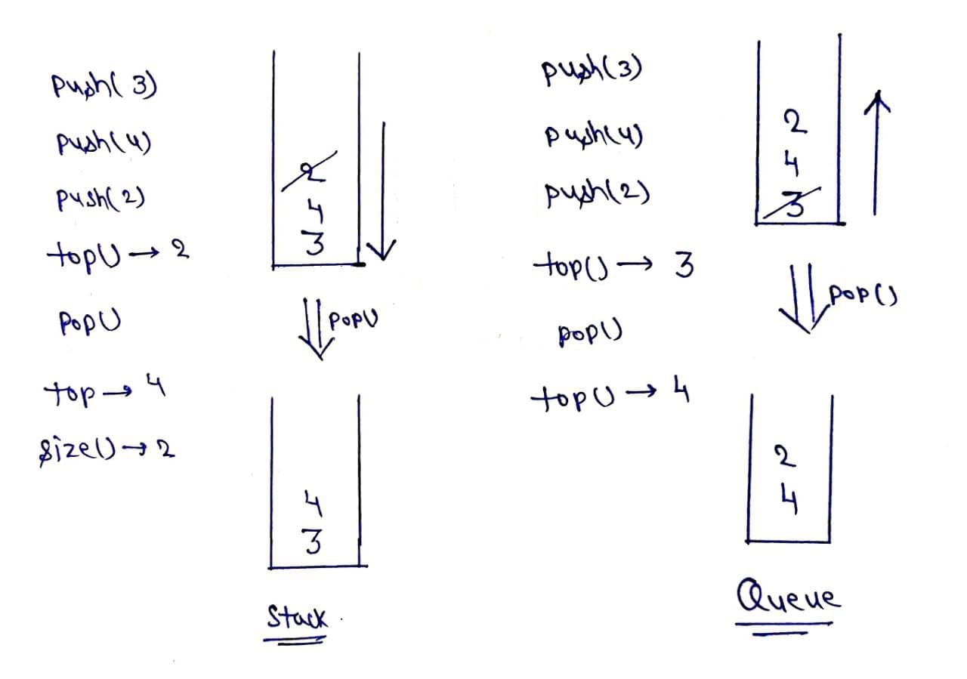

Explanation:
push(): Insert the element in the stack.
pop(): Remove and return the topmost element of the stack.
top(): Return the topmost element of the stack
size(): Return the size of the stack
Intuition: As we know stack follows last in first out, which means we get the most recently inserted element whenever we remove an element from the stack. But queue follows first in first out, it means we get that element which we inserted in the starting at each deletion, it means if we want to use the queue like a stack we have to arrange elements in the queue such that we get the most recent element at each deletion.
Approach:
- Take a single queue.
- push(x): Push the element in the queue.
- Use a for loop of size()-1, remove element from queue and again push back to the queue, hence the most recent element becomes the most former element and vice versa.
- pop(): remove the element from the queue.
- top(): show the element at the top of the queue.
- size(): size of the current queue.
Repeat step3 at every insertion of the element.
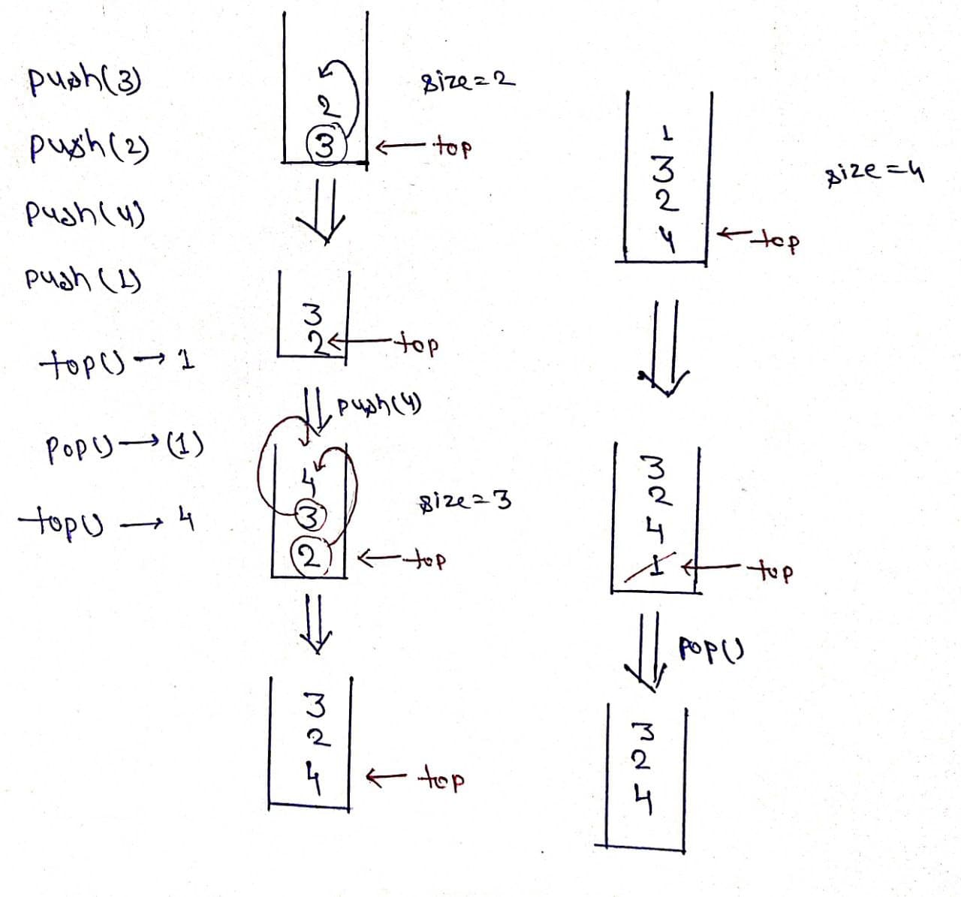
Code:
class MyStack {
public void push(int x) {
q.offer(x);
for (int i = 0; i < q.size() - 1; ++i)
q.offer(q.poll());
}
public int pop() {
return q.poll();
}
public int top() {
return q.peek();
}
public boolean empty() {
return q.isEmpty();
}
private Queue<Integer> q = new ArrayDeque<>();
}

